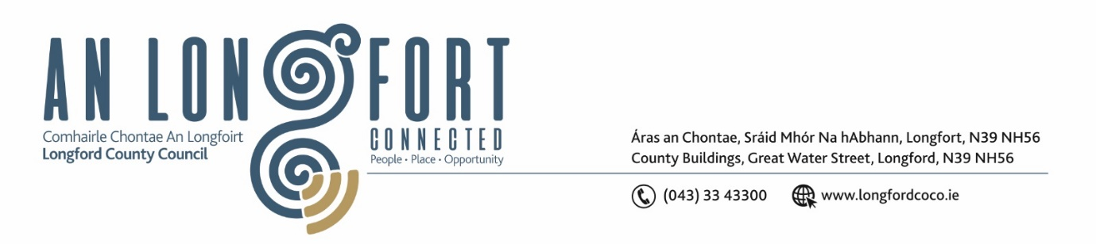

***Please note meeting will be held in the Council Chamber and via Microsoft Teams.***

12 Eanair 2023

**Chuig: Gach Ball don Chomhairle**

A Chomhairleoir,

Iarrtar ort bheith i láthair ag Cruinniú Míosuil Chomhairle Chontae Longfoirt a tionólfar i Seomra na Comhairle, Aras an Chontae, Longford agus via MS Teams are an **Chéadaoin 18ú Eanair 2023 ag** **4pm** chun gnó a dhéanamh d’réir an Chláir thíos.

You are requested to attend the Monthly Meeting of Longford County Council to be held in the **Council Chamber and via Microsoft Teams** on **Wednesday 18 January 2023 at 4pm** to transact business, as set out on the Agenda hereunder.

Mise le meas,

**__________________**

***Claire McNabola***

***Meetings Administrator.***

**C L Á R**

Prayer before meeting.

**1.** Confirmation of Minutes of Monthly Meeting of Longford County Council held on 14 December 2022 – copy enclosed.

**2.** Matters Arising.

**3.** Declaration of Interest by Members.

**4.** To note Management Report – to follow.

**5.** To note adopted Minutes of Corporate Policy Group Meeting held on the

8 November 2022 – enclosed.

**6. Housing, Planning, Regeneration & Capital Projects**

**(a)** To note Planning Applications received since last meeting of the Council.

**(b)** Consideration of disposal of Property at Gaigue, Ballinamuck, Co. Longford in accordance with the terms of Section 183 of the Local Government Act 2001 issued on the 22 December 2022 – as circulated.

**7. Community, Corporate and Enterprise**

**(a)** Consideration of Progress Report on Irish Language Scheme (Official Languages Act,

2003) – enclosed.

**(b)** Consideration and adoption of Annual Service Delivery Plan 2023 – to follow.

**(c)** Item referred from Placemaking Strategic Policy Committee meeting held on 14 December 2022:

* Consideration of draft Creative Ireland Strategy - enclosed.

**(d)** Approval to the appointment of Ms. Veronica Brennan, nominee of the Health Service Executive, to replace Ms Valerie Hand as a member of Longford Local Community Development Committee (LCDC).

**(e)** Consideration of Civic Reception – All-Ireland winning Longford Slashers Ladies Football Team.

**(f)** Political Donations - Local Elections (Disclosure of Donations and Expenditure) Act 1999, as amended - Members of Local Authorities – enclosed.

**(g)** Political Donations - Local Elections (Disclosure of Donation and Expenditure) Act

1999, as amended - Third Parties – enclosed.

**(h)** Proposed agreement of friendship and cooperation with the office of the Maryland Secretary of State.

**(i)** Notice of Motions, submitted by Councillors, as listed hereunder

**Councillor Seamus Butler**

That Longford County Council includes for the enablement of a suitably serviced site in the Longford Town area in the current Capital Budget to assist the construction of the IDA commitment for an Advanced Industrial Facility.

**8. Infrastructure and Innovation**

1. Deputation – Transport Infrastructure Ireland.

**(b)** Notice of Motions, submitted by Councillors, as listed hereunder

**Councillor Seamus Butler**

That Longford County Council request the Minister Eamonn Ryan and Minister of State Jack Chambers to meet a representative deputation of Council members to highlight the urgency of the N4 from Mullingar to the Leitrim border improvement programme. Further fatalities are inevitable until this vital section of infrastructure is put in place.

**9.**  **Correspondence**

1. Correspondence dated 12 December on affordable housing – Notice of motion submitted by Councillor Gerry Warnock.
2. Correspondence dated 8 December on Additional Resources to Planning Department – Notice of motion submitted by Councillor Uruemu Adejinmi

**10. Training – enclosed.**

**11. Votes of Sympathy**